DOWNLOADED HOLDING STATEMENT ON PORTFOLIO DATE 15-01-2021

Verify face value of security: 010503101

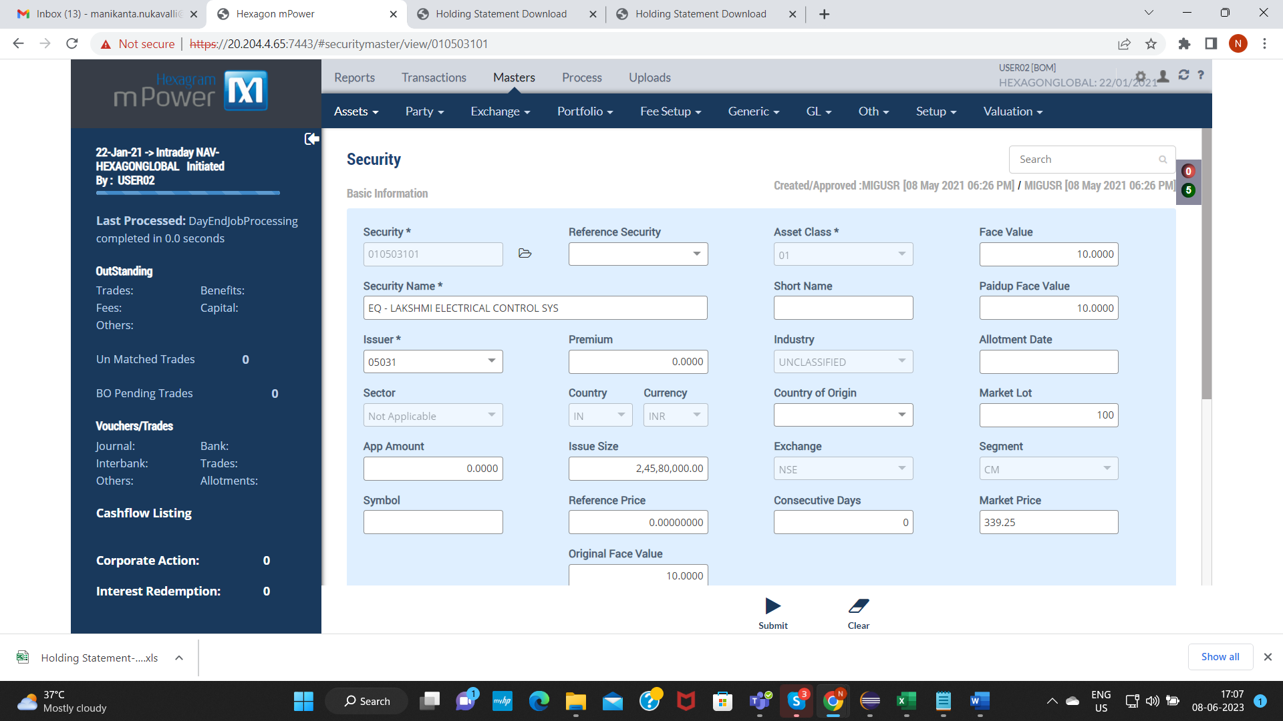

CREATE CORPORATE ACTION FOR BONUS 1:2 – BF210000457

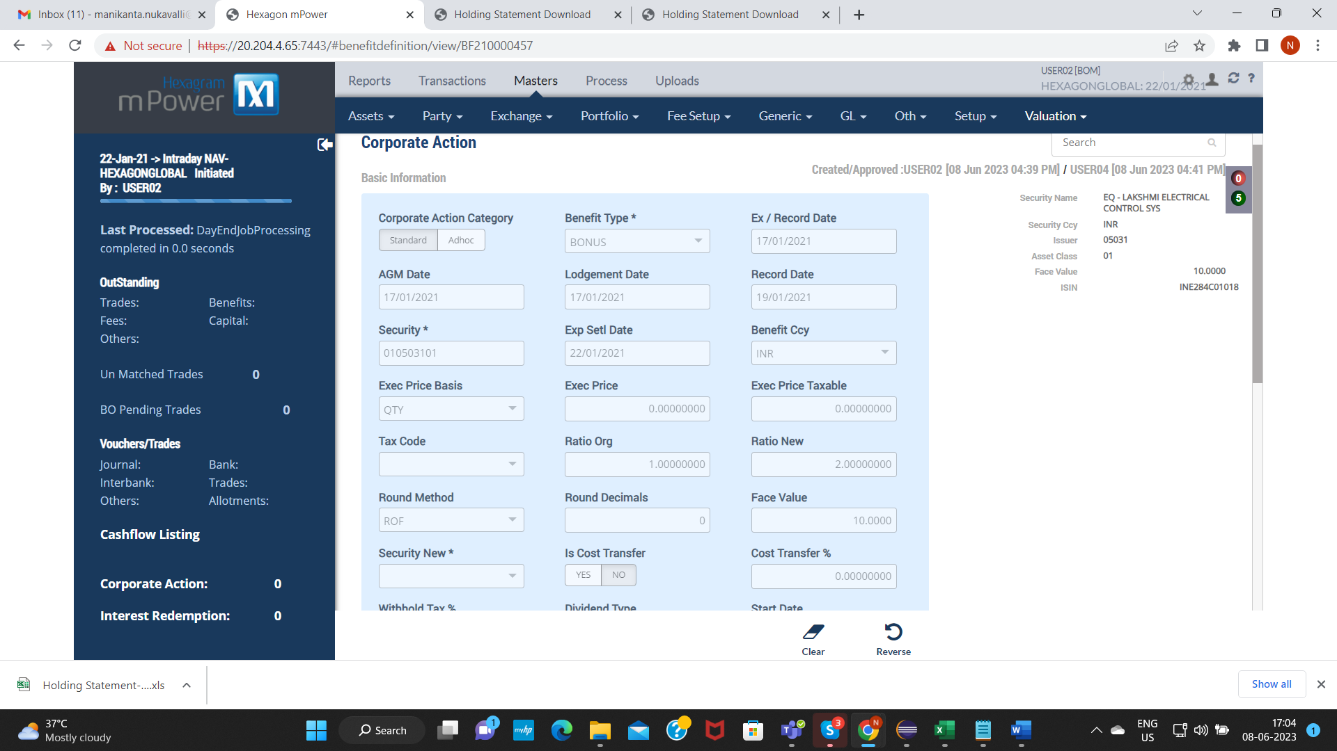

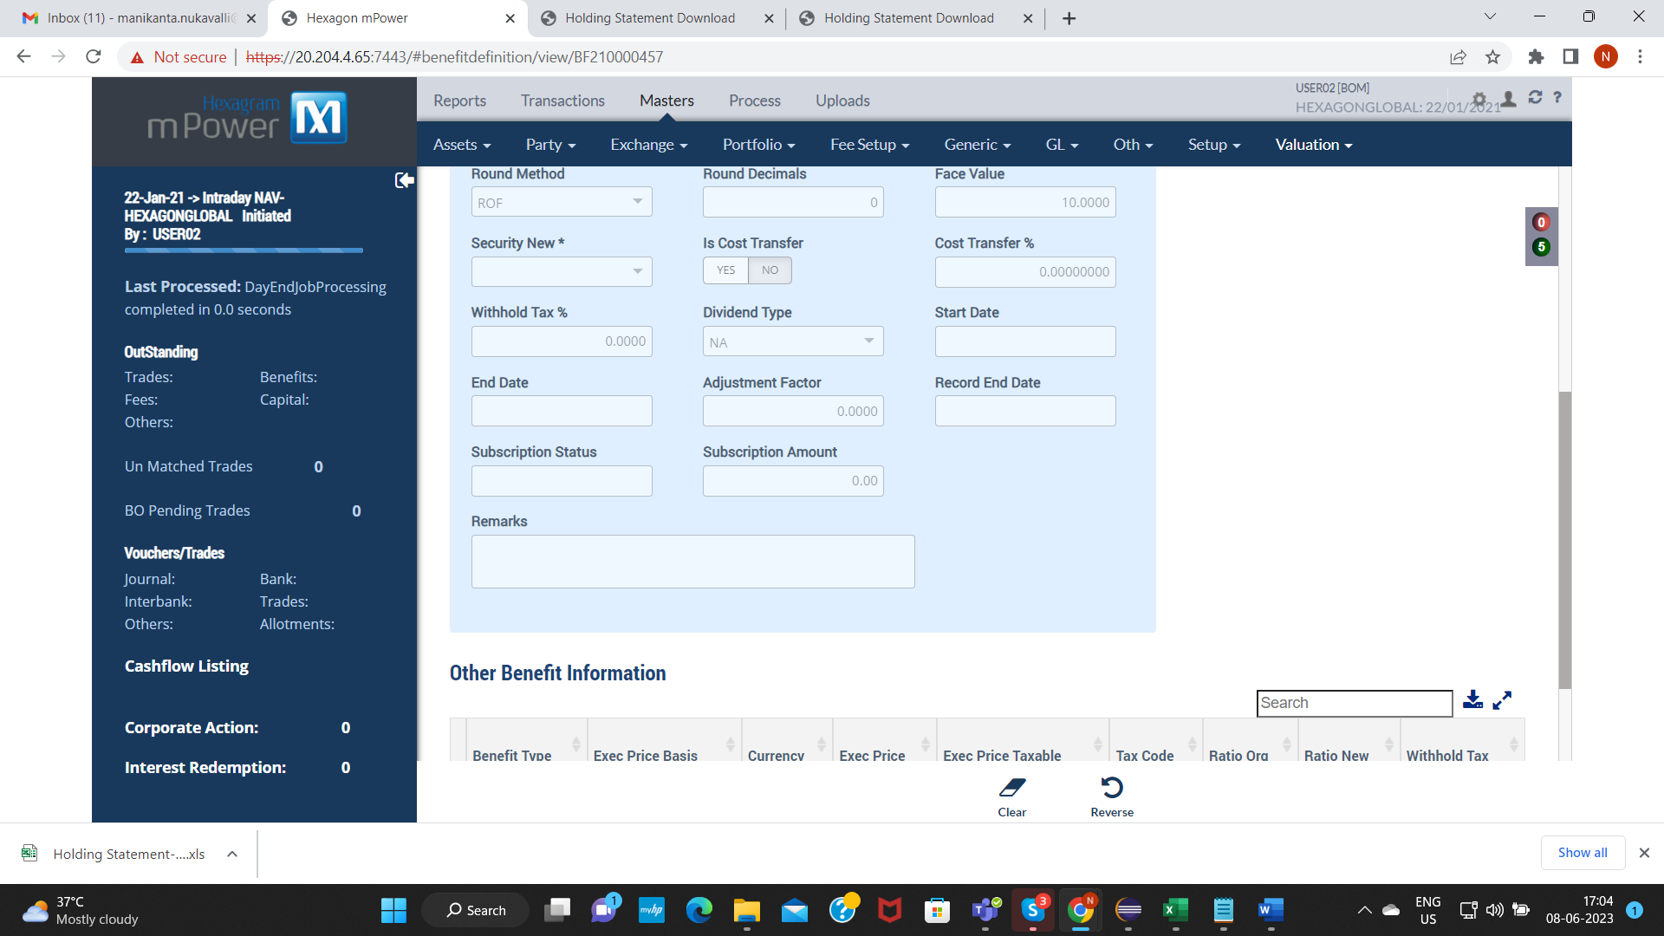

Create Settlement Transaction for Bonus 1:2 - TS21008307480000002

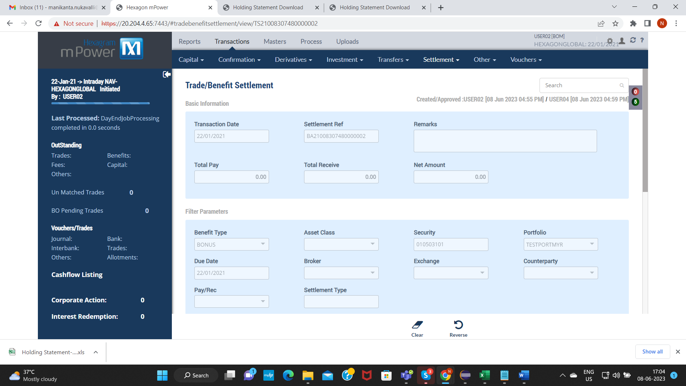

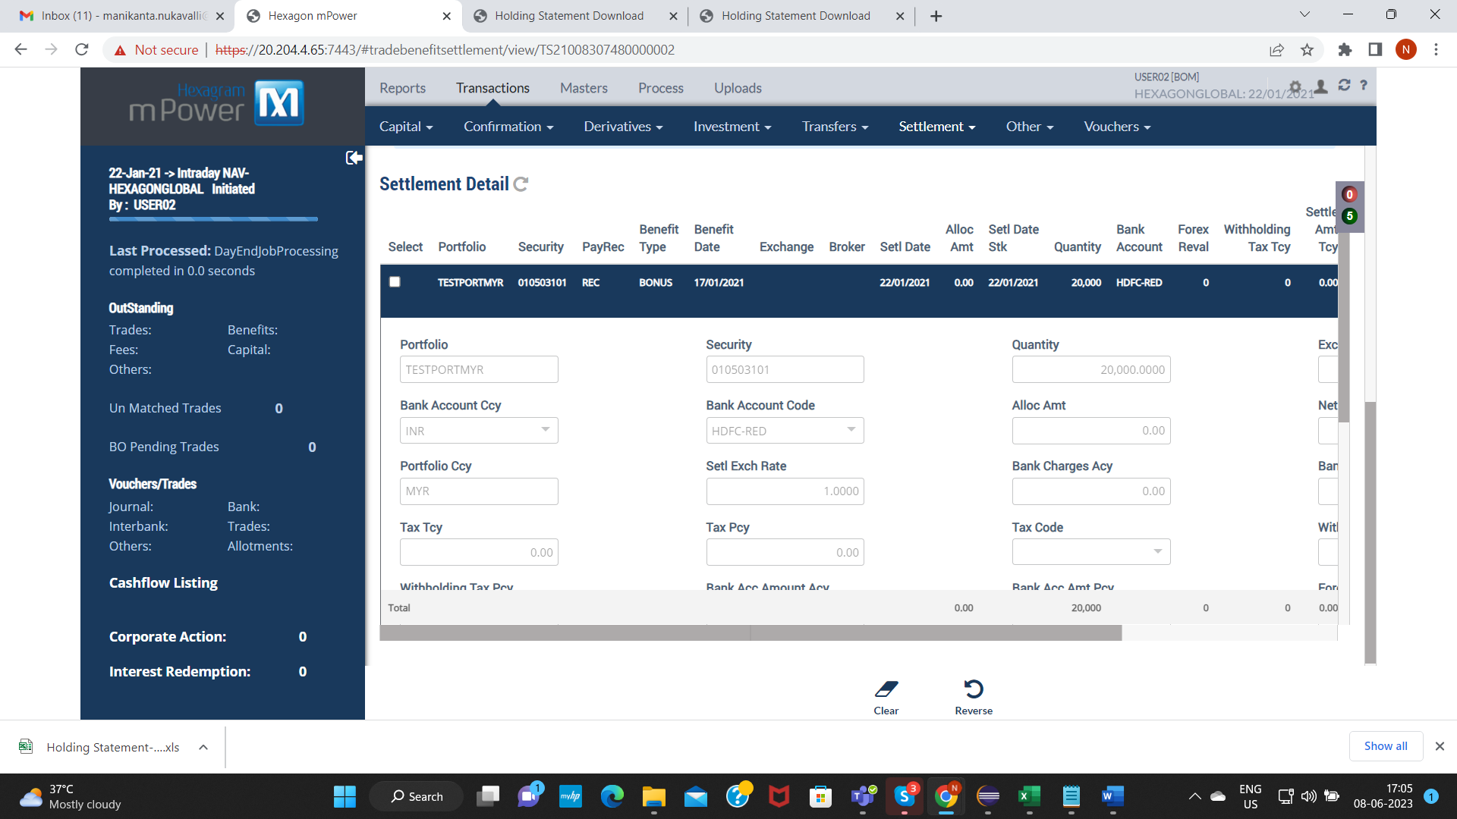

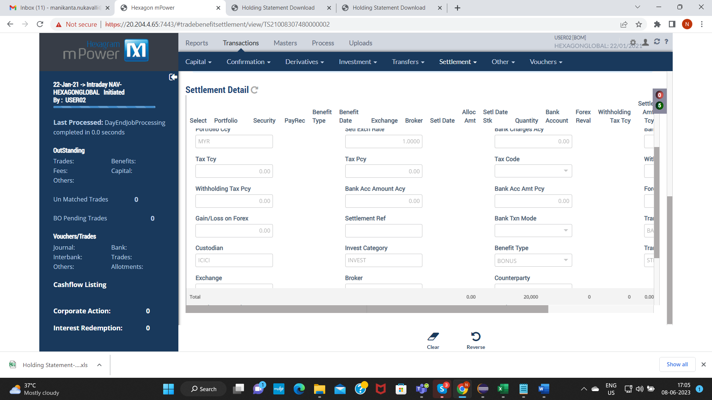

Verify Holding Statement on Settlement date – 22-01-2021

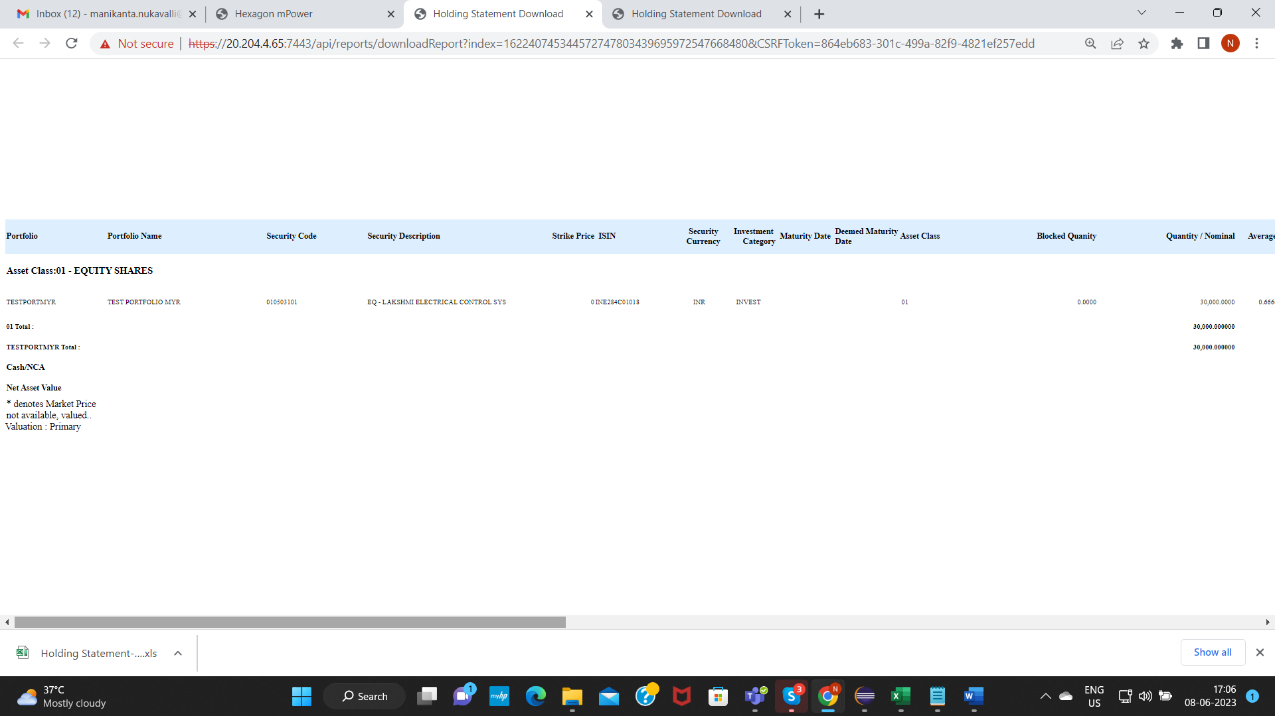

Verify security face value : Before – 10 After CA: 10

